1. Pirating software is an act of violating-

a. Equity b. Ethics c. Law d. None of the these

2. Publishing false information in internet is an issue of-

a. Computer ethics b. Morality c. Computer equity d. Digital Divide

3. Ethics must guide technology in the direction of

a. Political justice. b. Cultural justice. c. Social justice. d. None of the Above.

4. Supposing you are a journalist, is it ethical to use a tape record your Interview process without the consent of the person concerned?

a) Yes b) No c) Do not know d)None of these

5. "We wish to be good citizens of every community in which we operate." This is

A. Ethical Code B. Political and Social Code C. Legal Rule D. Legal Act

6. If you believe in making decisions for the good of most people, you can be described as following which school of thought?

A. utilitarianism B. teleology C. deontology D. Egoism

7.   Which statement is/are true?

|  |  |
| --- | --- |
| [A.](javascript:void(0);) | Ethics is not synonymous to religious morality or moral theology |
| [B.](javascript:void(0);) | Ethics is the principle that guide the human behaviour |
| [C.](javascript:void(0);) | The terms 'ethics' and 'morality' are not synonymous terms |
| [D.](javascript:void(0);) | All of the above |

8. Business ethics deals primarily with

|  |  |
| --- | --- |
| [A.](javascript:void(0);) | social responsibility |
| [B.](javascript:void(0);) | the pricing of products and services |
| [C.](javascript:void(0);) | moral obligation |
| [D.](javascript:void(0);) | being unfair to the competition |

9. A philanthropist is someone who

|  |  |
| --- | --- |
| [A.](javascript:void(0);) | buys products which have a positive impact on society |
| [B.](javascript:void(0);) | boycotts products which have a negative impact on society |
| [C.](javascript:void(0);) | both (a) and (b) |
| [D.](javascript:void(0);) | recognises the social impact of business on society |

10. Kavita is an ethically centered production manager so she will ship a product

|  |  |
| --- | --- |
| [A.](javascript:void(0);) | only after all its problems have been eliminated |
| [B.](javascript:void(0);) | only if the shipping people use packing material that does not harm the environment |
| [C.](javascript:void(0);) | only after an ethics committee has approved it |
| [D.](javascript:void(0);) | as quickly as she can to meet the customer's schedule |

11. Decisions and policies that use the _____________approach to decision making attempt to implement social systems, institutions, and environments that everyone depends on and that benefit all people.

a) Utilitarian b) Common good c) Fairness d) Virtue Ethics

12. A person who acts with ________acts in accordance with a personal code of principles

a) Ethics b) Integrity c) Morals d) Virtue

13. The________________ approach to decision making suggests that when faced with a complex ethical dilemma, people do either what they are most comfortable doing or what they think a person they admire would do.

a) Utilitarian b) Common good c) Fairness d) Virtue Ethics

14.  ______________is the concept that an organization should act ethically by taking accountability for the impact of its actions on the environment, the community, and the welfare of its employees.

a. Corporate social responsibility b. Corporate governance

c. Corporate social entrepreneurship d. Corporate sustainability

15. Which of the following statements best describes a reason why organizations pursue corporate social responsibility (CSR) goals and promote a work environment in which employees are encouraged to act ethically when making business decisions?

a. To enjoy higher employee turnover rates

b. To define a variable approach for dealing with stakeholders

c. To gain the goodwill of the community

d. To increase unfavourable publicity

16. The step in the decision-making process during which the decision makers consider laws, guidelines, policies, and principles that might apply to the decision is the ____________step.

a. develop problem statement b. implement decision

c. identify alternatives d. evaluate and choose alternative

17. Which of the following is the most critical step in the decision-making process?

a. Evaluation of the results b. Identification of alternative solutions

c. Development of a problem statement d. Implementation of a decision

18. In a for-profit organization, it is the primary objective of the to oversee the

organization’s business activities and management for the benefit of shareholders, employees, customers, suppliers, and the community.

a. negotiator b. board of directors

c. corporate ethics officer d. corporate compliance officer

19. A(n)___________ is a statement that highlights an organization’s key ethical issues and identifies the overarching values and principles that are important to the organization and its decision making

a. Code of ethics b. Mission

c. Vision d. Policy

20. A complication of the_________ approach to decision making is that measuring and comparing the values of certain benefits and costs is often difficult, if not impossible.

a. fairness b. virtue ethics c. common good d. utilitarian

21. 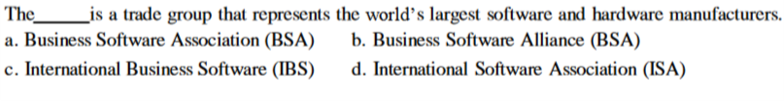

22. 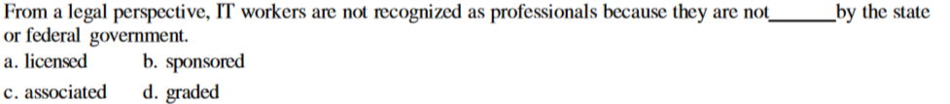

23. 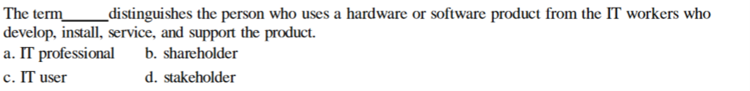

24. 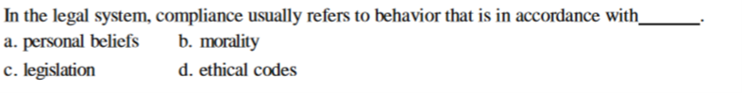

25. Decision-making in professional practice and ethical practice

1. involves very different methodologies.
2. involves a similar strategy and process.
3. should be considered separate issues.
4. should be left to supervisors and administrators.

26. A written statement of policies and principles that guides the behaviour of all employees is called

A. code of ethics B. word of ethics C. ethical dilemma

D. None of the above

1. B
2. A
3. C
4. B
5. A
6. A
7. D
8. C
9. D
10. A
11. B
12. B
13. D
14. A
15. C
16. D
17. C
18. B
19. A
20. D
21. B
22. A
23. C
24. C
25. B
26. A

sources

1-4 <http://www.tripurauniv.in/main/images/universitymedia/Examination/DM.pdf>

5-10 <https://www.avatto.com/ugc-net-exam/management/mcqs/ugc-net/questions/488/1.html>

11-20 <https://www.academia.edu/35483639/Test_Bank_Ethics_in_Information_Technology_5th_Edition>

20-24 <https://issuu.com/dr.mohamed4/docs/ch02_ethics_for_it_workers_and_it_u>

25-26 http://wps.ablongman.com/ab_sperry_issues_1/49/12757/3266008.cw/content/index.html

Question 1 E-government is:-

1. can be defined as 'controlling the operation and use of the use.'
2. the same as Internet governance.
3. can be defined as 'the application of e-commerce technologies to government and public services.'
4. can be defined as 'increasing the participation in Internet use by socially excluded groups.'

Ans:- C

Q2:- Software piracy is:

1. software counterfeiting.
2. the copying of software for use on more than one machine when the license is for single usage.
3. downloading pirate versions of software over the Internet.
4. client/server overuse of licences.
5. All of above

Ans:-E

Q3:- Which is not a reason a business engages in business ethics?

A) To recover a company’s image after a notorious business scandal

B) To avoid the loss of a good corporate image or being sued for misconduct

C) To enhance global relationships

D) To enhance stakeholder relationships

Ans: C

Q4: What are ethical theories?

A) Ethical theories are the conduct that should be followed in order to have good ethical practices

B) Ethical theories are the rules and principles that determine right and wrong for any given situation

C) Ethical theories are ancient hypothesis’ on how to create good business practice

D) Ethical theories give guidelines on how to achieve a good corporate image

Ans:B

Q5: define Moral Relativism

1. Values determined by the society
2. Values Determined by the family.
3. Values determined by the any organization
4. Non of these

Ans:- A

Q6:- **Law** is the system of rules of conduct established by the government of a society to maintain

1. Justice
2. Consistency
3. None of these
4. Both A & B

Ans: A

Q7:- Ethics of justice

A) Innocent justice, Guilty justice, Intuitional justice

B) Retributive justice, Processes justice, Compliant justice

C) Innocent justice, Fraudulent justice, Negligent justice

D) Retributive justice, Procedural justice, Distributive justice

Ans:- D

Q8:- What is definition of sustainability?

a.Sustainability means the capacity of a business to survive over time whilst contributing to the local communities and protecting the local environments in which it operates.

b.Sustainability means that business must extend its goals beyond that of adding economic value, to incorporate adding environmental and social value also.

c.Sustainable development is development that meets the needs of the present without compromising the ability of future generations to meet their own needs.

d.All of above.

Ans: B

Q9: All definitions of Corporate Social Responsibility recognize that:

a) companies have a responsibility for their impact on society and environment.

b) the natural environment should be the main focus of CSR activities.

c) business ethics is a complex issue.

d) companies must pay equal attention to business ethics and sustainability

Ans:- A

Q10:- What is the main characteristic of the stakeholder approach?

a) The idea that many different groups have a legitimate interest in the corporation

b) It is a critical perspective on corporations and business.

c) A focus on social and environmental responsibilities of a corporation.

d) The assumption that shareholders are not the main stakeholders in the corporation.

Ans:- A

Q11:- Opportunities for social innovation are greatest when:

a) CSR is aligned with a firm's core skills and capabilities.

b) CSR spending of a firm is larger than that of its competitors.

c) CSR is pursued by a firm to improve its reputation.

d) CSR is pursued by a firm to enhance human capital.

Ans:- A

Q12:- what is the problem definition related to:

1. How often does the problem occur?
2. What is the impact of the problem?
3. Only A
4. Only B
5. Both A and B

Ans:- E